Title, Times New Roman, Bold, font size 14

Authorª,*, Author^{b}
ªAffiliation, Country
Email: xxx@mail.xxxx

^{b}Affiliation, Country

Abstract

The template serves as a submission guideline for authors interested to submit their papers to the International Conference on Contemporary Economic Issues 2016 (ICCEI 2016). The first page of the submitted paper should include the title of the paper and the name and affiliation of each author. If there is more than one author for the paper, the corresponding authors should be clearly marked with an asterisk (*) and email address. Three to five keywords must be given as below. Abstract must be written in English or Bahasa Malaysia not exceeding 300 words. Abstracts should clearly state the aims of study, methodology used, results and conclusions.

Keywords: Abcde; Fghij; Klmnop.

1. Introduction

Papers in various areas of economics that include but not limited to Economic Growth and Development, Financial Economics and Globalization, Quality of Life are invited to be submitted and presented at this conference.

  - Main Text

The paper should be in A4 size, single-column format, using Times New Roman 12 point font with normal text spacing, and one-inch (2.5 cm) margins throughout the entire paper. Paper should not exceed 8 pages all-inclusive. Paper that does not follow the format will be returned back to the author without review.

  - Tables and Figures

All tables, figures, graphs, or appendices should have suitable titles. It is advised that tables supplement the discussion in the paper and not duplicating or repeating the text.

Table 1: Axxxxxx
Source: xxxx
**Statistically significant at 5 percent significance level.
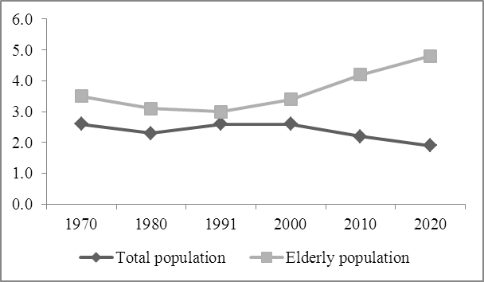
Figure 1: Trend of elderly population, 1970 – 2020

2. Submission and Proofreading

All papers should be sent electronically in MS Word-compatible file format to the ICCEI 2016 via the conference email at baliconference@usm.my. Authors are responsible in proof reading their own papers. The conference secretariat is not responsible for any editing work for the paper. Papers with extensive errors (grammar and spelling) will be returned back to authors without review.

Articles that previously published, under consideration by another conference or journal, and with pre-existing copyright may not be submitted for consideration.

3. Conclusion

Include conclusion and any policy implications here.

4. Acknowledgement

Acknowledgement is optional and should appear before references. The acknowledgement must be short and concise. Sponsorship and financial support acknowledgements should be included here. If no acknowledgement is necessary, this section should not appear in the paper.

5. References

References must be listed immediately following the conclusion or summary of the paper or after Acknowledgement. Please use Harvard referencing style, alphabetize by author and for each author list in chronological sequence. Please refer to this link for details. (http://libweb.anglia.ac.uk/referencing/harvard.htm)
Please do NOT list references as footnotes at the end of each page.

